

**Vidyavardhini’s**

**College of Engineering & Technology**

Vasai Road (W)

**Department of**

**Electronics and Telecommunication Engineering**

**Lab Manual**

|  |  |  |  |
| --- | --- | --- | --- |
| Semester | VIII | Class | BE |
| Course Code | ECL801 | Academic Year | R-2019 scheme |
| Course Name | Optical Communication Networks Lab | | |
| Name of Faculty | Mrs. Ashwini Katkar | | |
| Supporting Staff | Mrs. Madhu Lade | | |



**Vidyavardhini’s College of Engineering & Technology**

**Vision**

To be a premier institution of technical education, aiming at becoming a valuable resource for industry and society.

**Mission**

* To provide technologically inspiring environment for learning.
* To promote creativity, innovation and professional activities.
* To inculcate ethical and moral values.
* To cater personal, professional and societal needs through quality education.

**Department Vision:**

To contrive educational and research environment to serve industry and society needs in the field of electronics and telecommunication engineering.

**Department Mission:**

1. To enrich soft skills, ethical values, environmental and societal awareness.
2. To develop technical proficiency through projects and laboratory work.
3. To encourage students for lifelong learning through interaction with outside world.

**Program Education Objectives (PEOs):**

* The graduates will exhibit knowledge of mathematics, science, electronics, and communication, and will be able to apply the same in diversified field.
* The graduates will develop a habit of continuous learning while working in multidisciplinary environment.
* The graduates will grow as an individual with proficiency in technical skills, ethical values, communication skills, teamwork and professionalism.

**Program Specific Outcomes (PSOs):**

At the end of the program engineering graduate will be able to:

1. Apply the knowledge of Electronics and Communication to analyse, design and implement application specific problems with modern tools.
2. Adapt emerging technologies with continuous learning in the field of Electronics and Telecommunication engineering with appropriate solutions to real life problems.

**Program Outcomes (POs):**

Engineering Graduates will be able to:

* **PO1. Engineering knowledge:** Apply the knowledge of mathematics, science, engineering fundamentals, and an engineering specialization to the solution of complex engineering problems.
* **PO2. Problem analysis:** Identify, formulate, review research literature, and analyze complex engineering problems reaching substantiated conclusions using first principles of mathematics, natural sciences, and engineering sciences.
* **PO3. Design/development of solutions:** Design solutions for complex engineering problems and design system components or processes that meet the specified needs with appropriate consideration for the public health and safety, and the cultural, societal, and environmental considerations.
* **PO4. Conduct investigations of complex problems:** Use research-based knowledge and research methods including design of experiments, analysis and interpretation of data, and synthesis of the information to provide valid conclusions.
* **PO5. Modern tool usage:** Create, select, and apply appropriate techniques, resources, and modern engineering and IT tools including prediction and modeling to complex engineering activities with an understanding of the limitations.
* **PO6. The engineer and society:** Apply reasoning informed by the contextual knowledge to assess societal, health, safety, legal and cultural issues and the consequent responsibilities relevant to the professional engineering practice.
* **PO7. Environment and sustainability:** Understand the impact of the professional engineering solutions in societal and environmental contexts, and demonstrate the knowledge of, and need for sustainable development.
* **PO8. Ethics:** Apply ethical principles and commit to professional ethics and responsibilities and norms of the engineering practice.
* **PO9. Individual and teamwork:** Function effectively as an individual, and as a member or leader in diverse teams, and in multidisciplinary settings.
* **PO10. Communication:** Communicate effectively on complex engineering activities with the engineering community and with society at large, such as, being able to comprehend and write effective reports and design documentation, make effective presentations, and give and receive clear instructions.
* **PO11. Project management and finance:** Demonstrate knowledge and understanding of the engineering and management principles and apply these to one’s own work, as a member and leader in a team, to manage projects and in multidisciplinary environments.
* **PO12. Life-long learning:** Recognize the need for and have the preparation and ability to engage in independent and life-long learning in the broadest context of technological change.

**Course Objectives**

|  |  |
| --- | --- |
| 1 | To build knowledge of the significance and fundamentals of optical fiber communication. |
| 2 | To calculate the performance parameters of an optical link and analyze the link. |
| 3 | To learn the purpose and performance characteristics of major elements in optical links. |
| 4 | To build knowledge of the design of optical link |

**Course Outcomes**

|  |  |  |
| --- | --- | --- |
| At the end of the course, students will be able to: | | Bloom’s Level |
| ECL801.1 | Observe different parameters for the propagation of light inside the optical fiber. | Level 4 |
| ECL801.2 | Examine fiber optic links to find propagation losses. | Level 4 |
| ECL801.3 | Observe the performance characteristics of the optical source and detector. | Level 4 |
| ECL801.4 | Examine the optical link to find bandwidth. | Level 4 |
| ECL801.5 | Estimate link power and rise time budget in an optical network. | Level 4 |
| ECL801.6 | Implement an optical network using the simulator. | Level 4 |

**Mapping of Experiments with Course Outcomes**

|  |  |  |  |  |  |  |
| --- | --- | --- | --- | --- | --- | --- |
| Experiment | Course Outcomes | | | | | |
| ECL  801.1 | ECL  801.2 | ECL  801.3 | ECL  801.4 | ECL  801.5 | ECL  801.6 |
| To determine the numerical aperture of an optical fiber | 3 |  |  |  |  |  |
| Intensity Modulation of Optical Signal |  |  | 3 |  |  |  |
| To measure attenuation in optical fiber |  | 3 |  |  |  |  |
| To find bending losses in given optical fiber |  | 3 |  |  |  |  |
| To plot the Characteristics curve for LED |  |  | 3 |  |  |  |
| To plot the Characteristics curve for photodetector |  |  | 3 |  |  |  |
| To set up fiber optic analog link |  |  |  | 3 |  |  |
| To calculate Link Power Budget for given parameters |  |  |  |  | 3 |  |
| To calculate Rise Time Budget for given parameters |  |  |  |  | 3 |  |
| To design a optical network using network Cisco Packet Tracer simulator |  |  |  |  |  | 3 |
| To design a optical network and apply dispersion compensation in given optic fiber using Optisym simulator |  |  |  |  |  | 3 |
| To examine Bit Error Rate |  |  | 3 |  |  |  |
| To observe field intensity variation of step index fiber using COMSOL | 3 |  |  |  |  |  |
| To plot the refractive index profile of step and graded index fiber | 3 |  |  |  |  |  |

**EXPERIMENT 1: NUMERICAL APERTURE OF OPTICAL FIBER**

**Aim:** To find the Numerical Aperture of the Optical Fiber of the plastic fiber with the kit using 660 nm wavelengths LED.

**Equipment:**

Scientech2501A with power supply, Patch cords, 0.5-meter fiber cable, Numerical Aperture measurement fig., steel rule

**Theory**:

Numerical aperture refers to the maximum angle of the light incident at the fiber which is internally reflected and is transmitted properly along the fiber. The cone formed by rotations of this angle along the axis of the fiber is the cone of acceptance of the fiber. The light ray should strike the fiber and within its cone of acceptance, else it is refracted out of the fiber core.

Consideration in a measurement: It is very important that the source should be properly aligned with the cable and the distance from the launched point and the cable be properly selected to ensure that the maximum amount of optical power is transmitted to the cable.

This experiment is best performed in a less illuminated room.

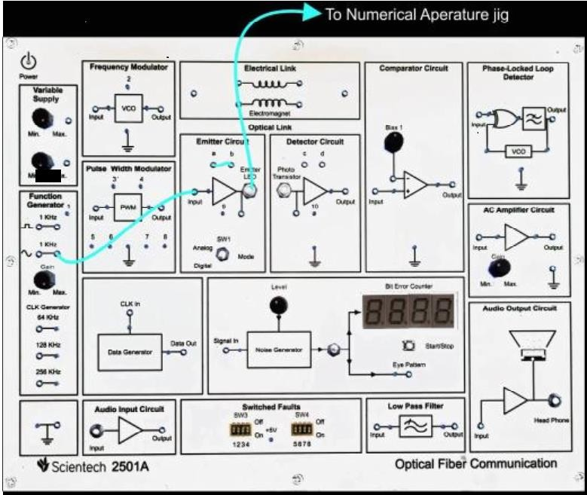**Connection Diagram:**

Figure 1 Connection diagram to find Numerical Aperture

**Procedure:**

* Connect the TechBook Power Supply with the mains cord to TechBook Scientech 2501A.
* · Put the mode switch SW1 to Digital to drive the emitter in digital mode.
* · Switch ‘On’ the Power Supply of TechBook and Oscilloscope.
* · Connect the Frequency Generator 1 KHz sine wave output to the input of the emitter
* circuit. Adjust its amplitude at 5Vp-p.
* · Connect one end of fiber cable to the output socket of the emitter circuit and the other end to the numerical aperture measurement jig. Hold the white screen.
* facing the fiber such that its cut face is perpendicular to the axis of the fiber.
* · Hold the white screen with 4 concentric circles (10, 15, 20 & 25 mm diameter) vertically at a suitable distance to make the red spot from the fiber coincide with the 10 mm circle.
* Record the distances of the screen from the fiber end L and note the diameter W of the spot.
* Find the numerical aperture of the fiber using the formula,

N.A. = sin θa =W/√4L𝟐+W𝟐

* Vary the distance between in screen and the fiber optic cable and make it coincide with one of the concentric circles. Note its distance.

· Tabulate the various distances and diameters of the circles made on the white screen and computer the numerical aperture from the formula given above.

**Observation Table:**

|  |  |  |  |
| --- | --- | --- | --- |
| Obs.  No. | Diameter (W) | Distance(L) | Numerical  Aperture NA |
| 1 |  |  |  |
| 2 |  |  |  |
| 3 |  |  |  |
| 4 |  |  |  |

**Result analysis and Conclusion:**

**Post Experiment Questions:**

* What is the significance of Numerical Aperture?
* Why is there any trade-off between NA and the Data rate of optical fibre?

**EXPERIMENT 2:** **INTENSITY MODULATION OF THE DIGITAL SIGNAL**

**Aim:** To obtain Intensity Modulation of the Digital Signal, transmit it over a fiber optic cable and demodulate the same at the receiver end to retrieve the original signal.

**Equipment Required**: Scientech 2501A TechBook with Power Supply cord Optical Fiber cable Scientech Oscilloscope with the necessary connecting probe.

**Connection Diagram:**

Figure 1: Connection Diagram for intensity modulation

**Procedure:**

**·** Connect the TechBook Power Supply with the mains cord to TechBook Scientech

2501A.

· Make the connections as shown in the next figure

Connect the 1 KHz square wave socket in the Function Generator block to emitter input.

Connect the fiber optic cable between the emitter output and detector input.

Connect the detector output to the comparator input.

· Put the mode switch SW1 to Digital to drive the emitter in Digital mode. This ensures that the signal applied to the driver input causes the emitter LED to switch quickly between ‘On’ & ‘Off’ states.

· Switch ‘On’ the Power Supply of TechBook and Oscilloscope.

· Examine the input to emitter on an Oscilloscope this 1 KHz square wave is now being used to amplitude modulates emitter LED.

· Examine the output of detector. This should carry a smaller version of original 1KHz square wave illustrating that the modulated light beam has been reconverted into an electrical signal.

· Monitor inputs of comparator and slowly adjust the comparator bias

potentiometer until the DC level on the negative input lies mid-way between the high & low level of the signal on the positive input. This DC level is comparator's threshold level.

· Examine the output of comparator. Note that the original digital modulating signal has been reconstructed at the receiver.

Once again carefully flex the fiber optic cable; we can see that there is no change in output on bending the fiber. The output amplitude is now independent of the bend radius of the cable and that of the length of the cable provided that the detector output signal is large enough to cross the comparator threshold level. This illustrates one of the advantages of amplitude modulation of a light beam by digital rather than analog means. Also, non-linear ties within the emitter LED & phototransistor distorting the signal at the receiver output are the disadvantages associated with amplitude modulating a light source by analog means. Linearity is not a problem if the light beam is switched ‘On’ & ‘Off’ with a digital signal since the detector output is simply squared up by a comparator circuit. To overcome problems associated with amplitude modulation of a light beam by analog means, analog signals are often used to vary or modulate some characteristic of a digital signal (e.g. frequency or pulse width.). The digital signal is used to switch the light beam ‘On’ & ‘Off’ The next two experiments illustrate how an analog signal can be used to modulate specific characteristics of a digital signal.

**Observations:**

Figure 2: Output at different stages

**Result Analysis and Conclusion:**

**Questions:**

1. What is intensity modulation?

2. How the modulated signal is detected?

**EXPERIMENT 3: ATTENUATION IN OPTICAL FIBER**

___________________________________________________________________________

**Aim:** Measurement of Propagation Loss or Attenuation in the optical fiber.

**Equipment:**

Scientech 2501A TechBook with power supply and mains used cord, Optical fiber cable, Scientech oscilloscope.

**Theory:**

Optical fibers are available in different variety of materials. These materials are usually selected by considering their absorption characteristics for different of light. In the core of optical fiber since signal is transmitted in the form of light which is completely different as that of the electron. One must consider the fiber losses. As light propagates from one end of the material exhibiting absorption loss also the part of the light is reflected or in some other direction loss. Plastic fiber has a higher loss of the order 180 dB/km. This occurs when θ is subjected to subtending bending power the radius of curvature moves in the loss. This is due to the coupling of fiber.

**Connection Diagram:**

Figure 1 Connection diagram for measurement of attenuation

**Procedure:**

1. Connect the TechBook Power Supply with mains cord to TechBook Scientech 2501A.

2. Make the connections as shown in next figure

3. Connect the Function Generator 1 KHz sine wave output to emitter input.

4. Connect 0.5 m optic fiber between emitter output and detector input.

5. Connect Detector output to amplifier input. ·

6. Put the mode switch SW1 to Analog to drive the emitter in analog mode.

7. Switch ‘On’ the Power Supply of TechBook and Oscilloscope.

8. Set the Oscilloscope channel 1 to 0.5 V/ Div and adjust 4-6 div amplitude by using X 1 probe with the help of variable potentiometer in Function Generator block at input of emitter.

9. Observe the output signal from detector on Oscilloscope.

10. Adjust the amplitude of the received signal as that of transmitted one with the help of gain adjusts pot in AC amplifier block. Note this amplitude and name it V1 . ·

11. Now replace the previous fiber optic cable with 1 m cable without disturbing any previous setting.

12. Measure the amplitude at the receiver side again at output of amplifier. Note this value end name it V2 .

13. Calculate the propagation (attenuation) loss with the help of following formula

**Result analysis and Conclusion:**

**Post Experiment questions:**

**1.** Explain the difference between attenuation and dispersion**.**

**2.** How to measure propagation losses?

**EXPERIMENT 4: BENDING LOSSES IN OPTICAL FIBER**

**Aim:**

To find the bending losses in optical fiber.

**Objective:**

The objective of this experiment is to measure bending loss in fiber.

**Equipments:**

Scientech 2501A TechBook with power supply and mains used cord, Optical fiber cable, Scientech oscilloscope, Mondtel

**Theory:**

Optical fibers are available in different variety of materials. These materials are usually selected by considering their absorption characteristics for different light. In the core of optical fiber since signal is transmitted in the form of light which is completely different from that of the electron. One must consider the fiber losses. As light propagates from one end of the material exhibiting absorption loss, also the part of the light is reflected or in some other direction loss. Plastic fiber has a higher loss of the order 180 dB/km. This occurs when θ is subjected to subtending bending power the radius of curvature moves in the loss. This is due to the coupling of fiber.

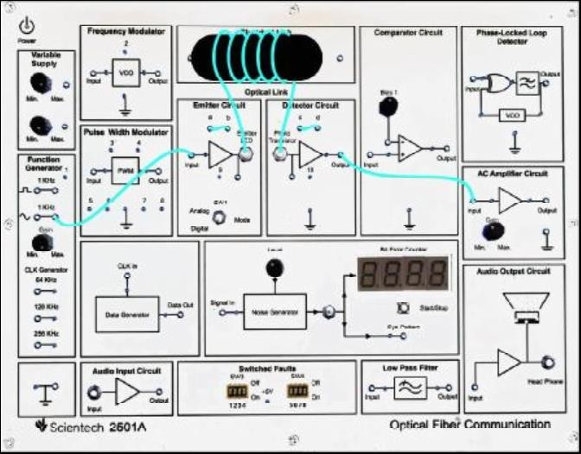**Connection Diagram**:

Figure 1 Connection diagram to find bending losses

**Procedure:**

1. Connect the TechBook power supply with the main cord to the TechBook Scientech 2501A.
2. Make the connections as shown in the diagram.
3. Connect the function generator (1V, 1 KHz) sine wave output to emitter input.
4. Connect 1 m optic fiber between emitter output and detector input.
5. Connect detector output to amplifier input.
6. Put the mode switch SW1 to analog to drive the emitter to analog mode.
7. Switch ON the power supply of TechBook and oscilloscope.
8. Touch the power symbol for a few seconds to switch ON the TechBook. The power symbol is given at top left-side position.
9. Adjust the amplitude of the received signal as that of the transmitted one with the help of gain adjusts potentiometer in the AC amplifier block. Note this amplitude name it V1.
10. Wind the fiber optic cable on the Mondtel and observe the corresponding AC amplifier output on the oscilloscope, it will be gradually reducing, showing loss due to bends.
11. Observe the output signal from the detector on an oscilloscope.

**Observation Table:** Vin =

|  |  |
| --- | --- |
| Number of turns | Output voltage Vo (v) |
| 1 | 0.8 |
| 2 | 0.28 |
| 3 | 0.22 |

**Result analysis and Conclusion:**

**Post experiment questions:**

1.Explain your understanding of radius of curvature in optical communication.

2.What is the reason for bending losses?

**EXPERIMENT 5: V-I CHARACTERISTICS OF PHOTO LED**

**____________________________________________________________**

**Aim:** To study characteristics of photo LED.

**Equipments:**

Scientech 2501 ATechBook with Power Supply cord, Optical Fiber cable, Scientech Oscilloscope with necessary connecting probe, Digital Multimeter

**Theory:**

LED’s and LASER diodes are the commonly used sources in optical communication systems, whether the system transmits digital or analog signals. It is therefore often necessary to use linear electrical to optical converter to allow its use in intensity modulation & high-quality analog transmission systems. LED's have a linear optical output to the forward current over a certain region of operation.

**Connection Diagram:**

Figure 1 Set up for VI characteristics of LED

**Procedure:**

1. Connect the TechBook Power Supply with the mains cord to TechBook Scientech 2501A.
2. Ensure that all switched faults are in OFF condition. ·
3. Put the mode switch SW1 to Digital to drive the emitter in Digital mode. ·
4. Make connections as shown in the above figure.
5. Connect the variable Power Supply 1 to the emitter input.
6. Keep the level of the supply to a minimum position.
7. Connect an Ammeter between points ‘a’ and ‘b’ to measure the forward current (If).
8. Connect a Voltmeter between emitter input and variable Power Supply 2 to measure the forward voltage (Vf).
9. Keep the level of the supply to the maximum position. It measures the voltage drop across the 1kohms (connected in series with Photo LED) current limiting resistors.
10. Switch ‘On’ the Power Supply of TechBook and Oscilloscope.
11. Adjust the Power Supply potentiometer to its minimum setting fully counterclockwise.
12. Now look down at the emitter LED socket and slowly advance the setting of the potentiometer until in subdued lighting the light from the LED is just visible.
13. Vary the potentiometer gradually to vary the forward voltage (as 1.5, 2.0…..), note the corresponding If (forward current).
14. Record these values of (Vf) and (If) & plot the characteristic between these two.

**Observation Table:**

|  |  |  |
| --- | --- | --- |
| Sr No | Voltage (Vf) | If(mA) |
| 1 | 1.8 | 0.77 |
| 2 | 1.98 | 2.17 |
| 3 | 2.13 | 5.4 |
| 4 | 2.36 | 5.89 |
| 5 | 2.7 | 5.96 |
| 6 | 3.01 | 6 |
| 7 | 3.85 | 6.01 |
| 8 | 4 | 6.04 |
| 9 | 5 | 6.04 |

**Result analysis and Conclusion:**

**Post Experiment Question:**

1. Write a minimum of four points for Comparison between Spontaneous and Simulated emission.

2. Differentiate between homojunction and heterojunctions.

**EXPERIMENT 6: V-I CHARACTERISTICS OF PHOTODETECTOR**

**___________________________________________________________________________**

**Aim:**

To study characteristics of photodetector.

**Equipments:**

Scientech 2501 ATechBook with Power Supply cord, Optical Fiber cable, Scientech Oscilloscope with necessary connecting probe, Digital Multimeter

**Theory:** Photo Transistors and Photo Diodes are the commonly used detectors in optical communication systems, whether the system receives digital or analog signals. It is, therefore, often necessary to use the linear optical-to-electrical converter to allow its use in intensity demodulation & high-quality analog receiving systems. Photo Diodes have a linear electrical output with relation to the light intensity over a certain region of operation.

**Connection Diagram:**

Figure 1 Set up for VI characteristics of Photodetector

**Procedure:**

1. Connect the TechBook Power Supply with the mains cord to TechBook Scientech 2501A.
2. Ensure that all switched faults are in OFF condition.
3. Put the mode switch SW1 to Digital to drive the emitter in Digital mode.
4. Make connections as shown in the next figure
5. Connect the variable Power Supply 1 to the emitter input.
6. Keep the level of the supply to a minimum position.
7. Connect a patch cord between points ‘a’ and ‘b’.
8. Connect the fiber optic cable between the emitter output and detector input.
9. Connect a Voltmeter between emitter input and variable Power Supply 2 to measure the forward voltage (Vf).
10. Keep the level of the supply to the maximum position.
11. It measures the voltage drop across the 1kohms (connected in series with Photo LED) current limiting resistors.
12. Connect an Ammeter between points ‘c’ and ‘d’ to measure the detector current (Id). · Switch ‘On’ the Power Supply of TechBook and Oscilloscope.
13. Adjust the Power Supply potentiometer to its minimum setting fully counterclockwise.
14. Now look down at the emitter LED socket and slowly advance the setting of the potentiometer until in subdued lighting the light from the LED is just visible.
15. Vary the potentiometer gradually to vary the forward voltage and note the corresponding detector current (Id).
16. Record these values of (Vf) and (Id) & plot the characteristics between these two.

**Observations:**

|  |  |  |  |
| --- | --- | --- | --- |
| Sr No | | Voltage (Vf) | Id(mA) |
| 1 | 1.05 | 0.21 | |
| 2 | 1.51 | 0.35 | |
| 3 | 1.58 | 0.46 | |
| 4 | 1.61 | 0.78 | |
| 5 | 1.7 | 3.19 | |
| 6 | 2.25 | 7.31 | |
| 7 | 3.3 | 7.3 | |
| 8 | 2.65 | 7.3 | |
| 9 | 4.2 | 7.3 | |

**Result analysis and Conclusion:**

**Post Experiment Questions:**

1. Explain the dependence of wavelength on responsivity.
2. How input signal is related to responsivity.

**EXPERIMENT 7: SETTING FIBER OPTIC ANALOG LINK**

**Aim:**

To study Setting the frequency response of a fiber 660 nm and 950 nm fiber optic analog link

**Equipments:**

Scientech2501A with power supply, Patch cords, 0.5-meter fiber cable, Numerical Aperture measurement fig., steel rule

**Theory:**

Fiber optic links can be used for the transmission of digital as well as analog signals. An optical fiber transmission link comprises the elements as shown in the figure. The key sections are a transmitter consisting of a light source and its associated drive circuitry, a cable offering mechanical and environmental protection to the optical fiber contained inside, and a receiver consisting of a photodetector plus amplification and signal-restoring circuitry. Additional components include optical connectors, splices, couplers or beam splitters, and repeaters.

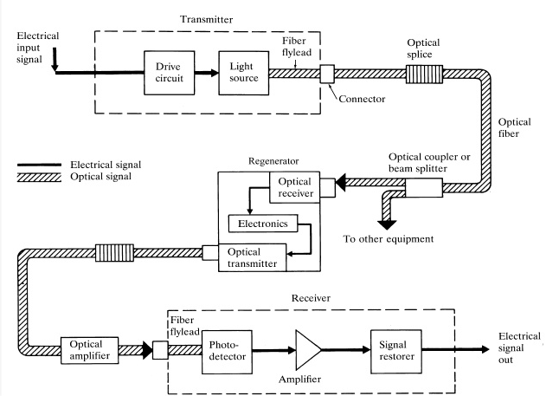

Figure 1 Fiber optic analog link

**Procedure:**

1. Connect the TechBook power supply with the mains cord to TechBookScientech 2501A.
2. Ensure that all switched faults are OFF.
3. Make the connection as shown in figure.
   * 1. Connect the external function generator sine wave output (1V, 1 KHz) to emitter input.
     2. Connect the fiber optic cable between emitter output and detector input.
     3. Connect the detector output to AC amplifier input.
4. Put the mode switch SW1 to analog to device the emitter in analog mode.
5. Switch ON the power supply of TechBook and oscilloscope.
6. Touch the power symbol for few seconds to switch on TechBook. Power symbol is given at left side top position of mimic near power connector.
7. Observe the output waveform voltage for frequency range from few KHz to few hundred KHz until the undistorted output is observed.
8. Plot the frequency response.

**Connection Diagram:**

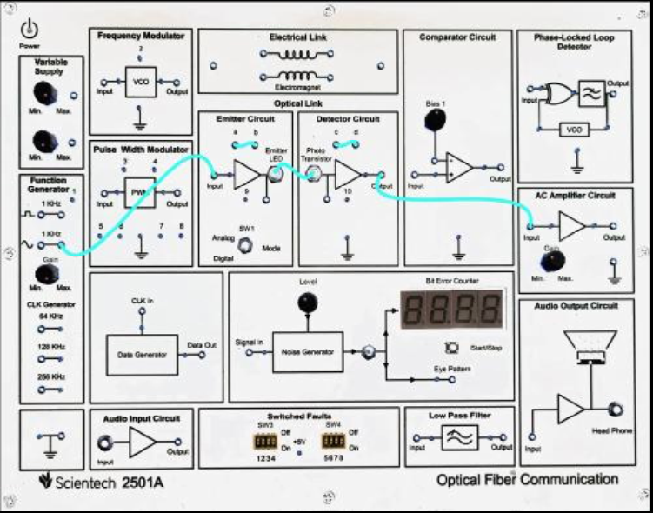

Connect the external function generator

Figure 2 Connection diagram for Fiber optic analog link

**Observation Table:** Vin =1V p-p

|  |  |  |  |
| --- | --- | --- | --- |
| Frequency (Hz) | Output Voltage (Vo) | Gain= | Gain (dB) |
| 40 | 1.5 | 1.5 | 1.76 |
| 60 | 2 | 2 | 3.01 |
| 100 | 2.4 | 2.4 | 3.802 |
| 300 | 2.5 | 2.5 | 3.98 |
| 400 | 2.5 | 2.5 | 3.98 |
| 700 | 2.5 | 2.5 | 3.98 |
| 1K | 2.5 | 2.5 | 3.98 |
| 2K | 2.5 | 2.5 | 3.98 |
| 5K | 2.4 | 2.4 | 3.802 |
| 30K | 2.2 | 2.2 | 3.42 |
| 100K | 1.2 | 1.2 | 0.79 |
| 300K | 0.4 | 0.4 | -3.99 |
| 700K | 0.3 | 0.3 | -5.22 |
| 1M | 0.1 | 0.1 | -6.49 |

**Result analysis and Conclusion:**

**Post Experiment Question:**

1. Explain the significance of the Bandwidth*Length product.

2. Discuss relationship between data rate and bandwidth.

**EXPERIMENT 08: LINK POWER BUDGET**

**___________________________________________________________________________**

**Aim: :** To calculate the power budget for an optical fiber link for the given parameters

**Objective**: To calculate the power budget for an optical fiber link to determine the actual power budget for the link and verify that it meets the required specifications.

**Software Used**: Matlab

**Theory:**

**Link Power Budget**: The purpose of power budget is to ensure that enough power will reach the receiver to maintain reliable performance during the entire system lifetime. The minimum average power required by the receiver is the receiver sensitivity. The average launch power is generally specified for each transmitter with optical powers expressed in dBm. Link power budget determines the power margin between the optical transmitter output and the minimum receiver sensitivity needed to establish a specified BER. In order to estimate the maximum fiber length we should specify the output power of the transmitter and the receiver sensitivity. We can also specify a system margin. The purpose of the system margin is to allocate a certain amount of power to additional sources of power penalty that may develop during the system lifetime. This margin can then be allocated to connector, splice and fiber losses, plus any additional margin required for possible component degradation, transmission-line impairments, or temperature effects. If the choice of components did not allow the desired transmission distance to be achieved, the components might have to be changed or amplifiers might have to be incorporated into the link.

Figure 1 Optical Link for Power Budget Analysis

If PC is the optical power emerging from the end of the fiber attached to the light source, and PR is the receiver sensitivity,

Then PT = PC - PR = αf L+2Lc + system margin

where Lc is the connector loss,

αf is the fiber attenuation in (dB/km)

and L is the transmission length in km

System margin is normally taken 6dB for LED and 8 dB for ILD.

**Code:**

clc; clear

all; close

all;

pin=input('Enter the mean input optical power launched into the fiber in dBm'); po=input('Enter

the mean incident optical power required at receiver in dBm');

αf =input('Enter the in the attenuation factor in the fiber');

Lsp=input('Enter the in the splice loss per km');

Lc=input('Enter the in the total connector losses');

M=input('Enter the required safety margin');

L=(pin-po-Lc-M)/( αf +Lsp);

disp('The maximum link length is');

disp(L);

**Result analysis and Conclusion:**

**Post Experiment Question**:

1.What is the significance of the Link Power Budget ?

2. How to determine power Margin?

**EXPERIMENT 09: RISE TIME BUDGET ANALYSIS**

**___________________________________________________________________________**

**Aim: :** To calculate the rise time budget for an optical fiber link for the given parameters

**Objective**: To calculate the rise time budget for an optical fiber to determine the maximum permissible rise time for a given optical signal transmitted over the fiber.

**Software Used**: Matlab

**Theory:**

Link Power Budget: Rise time budget analysis is a critical step in designing and optimizing high-speed optical communication systems. The rise time of an optical signal is a measure of how quickly the signal changes from one state to another, and it is an important parameter for high-speed communication. The rise time budget analysis involves determining the maximum permissible rise time for a given optical signal and ensuring that the actual rise time of the signal does not exceed this limit. The rise time budget analysis considers various factors that can affect the rise time of an optical signal, such as the characteristics of the optical transmitter, the fiber optic cable, and the optical receiver. It also considers any signal distortion or loss that may occur due to factors such as attenuation, dispersion, and nonlinear effects.

To perform a rise time budget analysis, researchers would first need to determine the required rise time for the optical signal based on the specific application and data rate requirements. They would then need to identify the maximum permissible rise time based on the characteristics of the optical components, the fiber optic cable, and any other factors that may impact the signal's rise time. Once the maximum permissible rise time has been determined, researchers can calculate the expected rise time budget for the optical link by taking into account the signal losses and other factors that may impact the rise time. They can then validate these calculations through experiments, such as the one described in the previous question, to ensure that the actual rise time of the signal meets the required specifications.

The rise time budget analysis is critical for ensuring that high-speed optical communication systems are designed and optimized for maximum performance and reliability. By taking into account the various factors that can impact the rise time of an optical signal, researchers can design and optimize optical systems that meet the specific requirements of their applications and ensure efficient and reliable communication.

Total system rise time is given by the formula,



Where, tt= Transmitter rise time

tr= Receiver rise time

tmodal= modal dispersion of the fiber

tmat= Material dispersion rise time

**Result analysis and Conclusion:**

**Post Experiment Question**:

1. What is the significance of the Rise time Budget?

2.How rise time is defined?

**EXPERIMENT 10: Design of Optical Network**

**___________________________________________________________________________**

**Aim:**

To design an optical network using Cisco Packet Tracer

**Objective:**

The objective of designing an optical network using Cisco Packet Tracer is to simulate and test the network architecture and configuration.

**Simulator:**

Cisco Packet Tracer 7.03 or advanced version

**Theory:**

Optical networks are a type of telecommunications network that use optical fibers to transmit information over long distances. Optical fibers are made of glass or plastic materials and use light signals to transmit information, which can travel at very high speeds and with minimal signal loss. Optical networks are commonly used for high-speed data transmission in industries such as telecommunications, internet service providers, and data centres.

Cisco Packet Tracer is a simulation tool that can be used to design and test network topologies and configurations, including optical networks. It can help network designers and administrators to visualize, configure, and troubleshoot network devices and protocols, and simulate real-world scenarios to ensure optimal network performance and security.

**Network Architecture:**

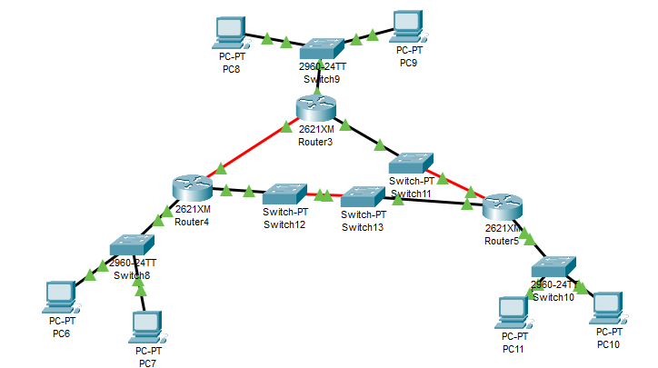

Figure 1 Optical Network Architecture in Cisco Packet Tracer

**Procedure:**

* Drag and drop PCs, Switches (2960), and routers (2621*M) type.
* Connect PCs, Switches, and routers on a single network using crossover connection (fast ethernet)
* Configure all PCs
* For each router select NM-1FE TX module.
* The NM-1FE-FX Module provides one Fast-Ethernet interface for use with fiber media. Ideal for a wide range of LAN applications, the Fast Ethernet network modules support many internetworking features and standards. Single port network modules offer autosensing 10/100BaseTX or 100BaseFX Ethernet.
* Now connect routers in different network using fiber gigabit connection.
* Create RIP routing table for all routers.
* Finally check the network connectivity using Ping command and also by sending packet from source to destination.

Output:

Output 1: -Ping Command

Output 2 :- Simulation

**Result analysis and Conclusion:**

**Post Experiment Question:**

1.Explain the concept of WDM.

2. Differentiate between CWDM and DWDM

**EXPERIMENT 11: Dispersion Compensation with Dispersion compensation Component**

**Aim:** To design a system with an Ideal Dispersion Compensation component in OptiSystem for dispersion compensation.

**Simulator:**

Optisystem Simulator 17.1

**Theory:**

Dispersion is the phenomenon by which different spectral components of a pulse travel at different velocities. The pulse-broadening effect of chromatic dispersion causes the signals in the adjacent bit periods to overlap. This is called intersymbol interference (ISI). Broadening is a function of distance as well as dispersion parameter D. The dispersion parameter is given in ps/nm/km and changes from fiber to fiber. Several techniques, including Dispersion Compensating Fiber or Fiber Bragg Grating, can be used to compensate the accumulated dispersion in the fiber.

**Diagram:**

Figure 1: Network Architecture in Optisim

**Procedure:**

Select the components from Default Library.

1. Open Optisytem
2. Default Library> Transmitter Library>User Defined bit sequence generators
3. Default Library> Transmitter Library>Pulse Generator>Optical Gaussian Pulse Generator
4. Default Library> Visualizers Library>Optical>Optical Time Domain Visualizer
5. Default Library> Visualizers Library>Optical>Optical Spectrum Analyser
6. Default Library> Optical Fiber Library>Optical Fiber.
7. Set the samples per bit and sequence length.
8. Save and run the simulation.
9. Observe output on Optical Visualiser before and after fiber
10. Measure total pulse spreading.
11. Insert dispersion compensation component and set to negative compensation for the dispersion occurred.

Observe output on Optical Visualiser after dispersion compensation component.

**Output:**

|  |  |  |
| --- | --- | --- |
| Optical Visualiser output Before Optical Fiber | Optical Visualiser output after optical Fiber | Optical Visualiser output after Dispersion Compensation |
|  |  |  |

**Result analysis and Conclusion:**

**Post Experiment Question:**

1.Dispersion hampers information carrying capacity of fiber. Justify

2.What is the impact of distance on length 0f the fiber.

**EXPERIMENT 12:** **To Measure Bit Error Rate**

**Aim:** To Measure the Bit Error Rate.

**Apparatus Required:**

· Scientech 2501A TechBook with Power Supply and mains cord

· Optical Fiber Cable

· Scientech Oscilloscope

**Theory:**

In telecommunication transmission, the bit error rate (BER) is a Ratio of bits that have

errors relative to the total number of bits received in a transmission. The BER is an

indication of how often a packet or other data unit has to be retransmitted because of

an error. Too high a BER may indicate that a slower data rate would improve overall transmission time for a given amount of transmitted data since the BER might be reduced, lowering the number of packets that had to be resent.

**Connection Diagram:**

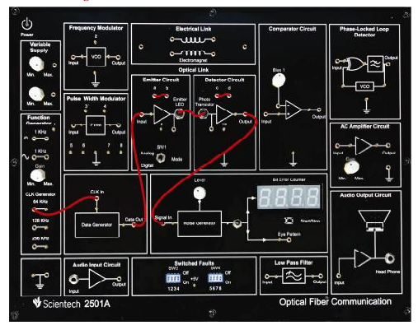

Figure Set up for measuring BER

**Procedure:**

· Connect the TechBook Power Supply with the mains cord to TechBook Scientech

2501A.

· Ensure that all switched faults are off.

· Make the connections as shown in next figure

Connect patch cords between ‘a & b’ and ‘c & d’.

Connect the 64 KHz Clock from the Clock generator to the Clock in the socket of the Data generator.

Connect the Data Generator output to the emitter input.

Connect the fiber optic cable between the emitter output and detector input.

Connect the detector output to the ‘Signal In’ socket of the Noise Generator.

· Put the selection switch towards the Bit Error Counter Block to count the bit error.

· Put the mode switch SW1 to Digital to drive the emitter in Digital mode. This ensures that the signal applied to the driver input causes the emitter LED to switch quickly between the ‘On’ & ‘Off’ states.

· Switch ‘On’ the Power Supply of TechBook and Oscilloscope.

· Initially Adjust the Level pot of the Noise Generator at the middle position.

· Press the Start/Stop switch and observe the Error Count on the 7-Segment Display of Bit Error Counter for any time duration ‘Td’ and press the Start/Stop switch again to stop.

· Record the readings for different clock frequencies/Time duration/Noise levels in the following observation table.

· Adjust the Level pot for minimum and maximum positions to observe the effect of variable noise on the error count.

**Measuring Bit Error Rate**

A BERT (bit error rate tester) is a procedure or device that measures the BER for a

given transmission. The BER, or quality of the digital link, is calculated from the

number of bits received with error divided by the number of bits transmitted.

BER= Bits received with Error /Total bits transmitted.

**Observation Table 1:**

|  |  |  |  |  |  |
| --- | --- | --- | --- | --- | --- |
| **Sr No** | **Clock Frequency (CLK)** | **Time Duration (Td)** | **Total no. of transmitted bits**  **N=CLK*Td** | **Bit Error Count (E)** | **Bit Error Rate=E/N** |
|  |  |  |  |  |  |
|  |  |  |  |  |  |
|  |  |  |  |  |  |

**Observation Table 2:**

|  |  |  |  |  |  |
| --- | --- | --- | --- | --- | --- |
| **Sr No** | **Clock Frequency (CLK)** | **Time Duration (Td)** | **Total no. of transmitted bits**  **N=CLK*Td** | **Bit Error Count (E)** | **Bit Error Rate=E/N** |
|  |  |  |  |  |  |
|  |  |  |  |  |  |
|  |  |  |  |  |  |

**Result Analysis and Conclusion**:

**Post Experiment Question:**

1. Discuss the trade-off between bandwidth and Bit Error Rate.

2.What is the significance of BER in designing reliable communication systems?

**EXPERIMENT 13: Field intensity variation through step index fiber using COMSOL.**

**Aim: To observe the field intensity variation of light signal passing through step index fiber using COMSOL.**

**Software Requirements: COMSOL**

**Theory:**

Understanding the theory behind the field intensity variation in a step-index optical fiber is crucial for designing and optimizing optical communication systems, where these fibers are commonly used for transmitting data through guided optical waves. Computational tools like COMSOL Multiphysics can be employed to simulate and analyze the behavior of light in such optical fibers, providing valuable insights into the field intensity distribution and its variations.

**Modelling Instructions:**

From the **File** menu, choose **New**.

**NEW**

In the **New** window, click **Model Wizard.**

**MODEL WIZARD**

1. In the **Model Wizard** window, click **2D**.
2. In the **Select physics** tree, select **Radio Frequency>Electromagnetic Waves, FrequencyDomain (emw)**.
3. Click **Add**.
4. Click **Study**.
5. In the **Select study** tree, select **Preset Studies>Mode Analysis**.
6. Click **Done**.

**GEOMETRY 1**

1. In the **Model Builder** window, under **Component 1 (comp1)** click **Geometry 1**.
2. In the **Settings** window for Geometry, locate the **Units** section.
3. From the **Length unit** list, choose **µm**.

Circle 1 (c1)

1. On the **Geometry** toolbar, click **Primitives** and choose **Circle**.
2. In the **Settings** window for Circle, locate the **Size and Shape** section.
3. In the **Radius** text field, type 40.

Circle 2 (c2)

1. Right-click **Circle 1 (c1)** and choose **Build Selected**.
2. On the **Geometry** toolbar, click **Primitives** and choose **Circle**.
3. In the **Settings** window for Circle, locate the **Size and Shape** section.
4. In the **Radius** text field, type 8.
5. Right-click **Circle 2 (c2)** and choose **Build Selected**.

**MATERIALS**

Material 1 (mat1)

1. In the **Model Builder** window, under **Component 1 (comp1)** right-click **Materials** and choose **Blank Material**.
2. In the **Settings** window for Material, type Doped Silica Glass in the **Label** text field.
3. Select Domain 2 only.

1. Click to expand the **Material properties** section. Locate the **Material Properties** section. In the **Material properties** tree, select **Electromagnetic Models>Refractive Index>Refractive index, real part (n)**.
2. Click **Add to Material**.
3. Locate the **Material Contents** section. In the table, enter the following settings:

|  |  |  |  |  |
| --- | --- | --- | --- | --- |
| **Property** | **Name** | **Value** | **Unit** | **Property group** |
| Refractive index | N | 1.4457 | 1 | Refractive index |
|  |  |  |  |  |

Material 2 (mat2)

1. Right-click **Materials** and choose **Blank Material**.
2. In the **Settings** window for Material, type Silica Glass in the **Label** text field.
3. Select Domain 1 only.

1. Click to expand the **Material properties** section. Locate the **Material Properties** section. In the **Material properties** tree, select **Electromagnetic Models>Refractive Index>Refractive index, real part (n)**.
2. Click **Add to Material**.
3. Locate the **Material Contents** section. In the table, enter the following settings:

|  |  |  |  |  |
| --- | --- | --- | --- | --- |
| **Property** | **Name** | **Value** | **Unit** | **Property group** |
| Refractive index | n | 1.4378 | 1 | Refractive index |
|  |  |  |  |  |

**ELECROMAGNETIC WAVE FREQUENCY DOMAIN (emw)**

Wave Equation, Electric 1

1. In the **Model Builder** window, expand the **Component 1 (comp1)>Electromagnetic Waves, Frequency Domain (emw)** node, then click **Wave Equation, Electric 1**.
2. In the **Settings** window for Wave Equation, Electric, locate the **Electric Displacement Field** section.
3. From the **Electric displacement field model** list, choose **Refractive index**.

**MESH 1**

1. In the **Model Builder** window, under **Component 1 (comp1)** click **Mesh 1**.
2. In the **Settings** window for Mesh, locate the **Mesh Settings** section.
3. From the **Element size** list, choose **Finer**. Click the **Build All** button.

**STUDY 1**

Step 1: Mode Analysis

1. In the **Model Builder** window, under **Study 1** click **Step 1: Mode Analysis**.
2. In the **Settings** window for Mode Analysis, locate the **Study Settings** section.
3. Select the **Search for modes around** check box.
4. In the associated text field, type 1.446.

The modes of interest have an effective mode index somewhere between the refractive indices of the two materials. The fundamental mode has the highest index. Therefore, setting the mode index to search around to something just above the core index guarantees that the solver will find the fundamental mode.

1. In the **Mode analysis frequency** text field, type c_const/1.55[um].This frequency corresponds to a free space wavelength of 1.55μm.
2. On the **Home** toolbar, click **Compute**.

**RESULTS**

Electric Field (emw)

1. Click the **Zoom Extents** button on the **Graphics** toolbar.
2. Click the **Zoom In** button on the **Graphics** toolbar.

The default plot shows the distribution of the norm of the electric field for the highest of the 6 computed modes (the one with the lowest effective mode index).

To study the fundamental mode, choose the highest mode index. Because the magnetic field is exactly 90 degrees out of phase with the electric field you can see both the magnetic and the electric field distributions by plotting the solution at a phase angle of 45 degrees.

Data Sets

1. In the **Model Builder** window, expand the **Results>Data Sets** node, then click **Study 1/Solution 1 (sol1)**.
2. In the **Settings** window for Solution, locate the **Solution** section.
3. In the **Solution at angle (phase)** text field, type 45.

Electric Field (emw)

1. In the **Model Builder** window, under **Results** click **Electric Field (emw)**.
2. In the **Settings** window for 2D Plot Group, locate the **Data** section.
3. From the **Effective mode index** list, choose **1.4444 (2)**.
4. In the **Model Builder** window, expand the **Electric Field (emw)** node, then click **Surface1**.
5. In the **Settings** window for Surface, click **Replace Expression** in the upper-right corner of the **Expression** section. From the menu, choose **Model>Component1>Electromagnetic Waves, Frequency Domain>Electric>Electric field>emw.Ez - Electric field, z component**.

1. On the **Electric Field (emw)** toolbar, click **Plot**. Add a contour plot of the H-field.
2. In the **Model Builder** window, right-click **Electric Field (emw)** and choose **Contour**.
3. In the **Settings** window for Contour, click **Replace Expression** in the upper-right corner of the **Expression** section. From the menu, choose **Model>Component1>Electromagnetic Waves, Frequency Domain>Magnetic>Magnetic field>emw.Hz - Magnetic field, z component**.
4. On the **Electric Field (emw)** toolbar, click **Plot**.

The distribution of the transversal E and H field components confirms that this is the HE11 mode. Compare the resulting plot with that in Figure.

**Result Analysis and Conclusion:**

**Post Experiment Questions**

1.

**EXPERIMENT 14: TO PLOT REFRACTIVE INDEX PROFILE OF STEP INDEX AND GRADED INDEX FIBER**

**Aim: TO PLOT REFRACTIVE INDEX PROFILE OF STEP INDEX AND GRADED INDEX FIBER**

**Objective:**

The objective of this experiment is to plot

(a) the refractive index profile with n1=1.5, ∆ = 0.01 and core radius=30 micrometer

for Step Index Fiber

(b) the refractive index profiles from n1 to n2 as a function of radial distance r ≤ a for

graded index fibers that have α values of 1 to 10. Assume the fibers have a 30 mm

core radius, n1 = 1.5 and ∆ = 0.01.

**SOFTWARE USED: Python**

**Theory:**

Optical fiber is the technology associated with data transmission using light pulses travelling along with a long fiber which is usually made of plastic or glass. Optical fibers are also unaffected by electromagnetic interference. The fiber optical cable uses the application of

total internal reflection of light. The fibers are designed such that they facilitate the

propagation of light along with the optical fiber depending on the requirement of power and

distance of transmission.

The types of optical fibers depend on the refractive index and mode of propagation of light.

The classification based on the refractive index is as follows:

**• Step Index Fibers**: It consists of a core surrounded by the cladding, which has a

single uniform index of refraction.

**• Graded Index Fibers**: The refractive index of the optical fiber decreases as the radial

distance from the fiber axis increases.

The classification based on the mode of propagation of light is as follows:

**• Single-Mode Fibers**: These fibers are used for long-distance transmission of signals.

• **Multimode Fibers:** These fibers are used for short-distance transmission of signals.

Depending upon mode of propagation and refractive index of the core, fibers are classified

as:

• Step index-single mode fibers

• Step index-Multimode fibers

• Graded index-Multimode fibers

The optical fiber with a core of constant refractive index n1 and a cladding of a slightly lower

refractive index n2 is known as step index fiber. This is because the refractive index profile

for this type of fiber makes a step change at the Cylindrical fiber.

The refractive index profile of Step Index fiber may be defined as:

η1 r < a (Core)

η(r) = η2 r ≥ a (Cladding)

Graded index fibers do not have a constant refractive index in the core but a

decreasing core index n(r) with radial distance from a maximum value of n1 at the axis to a

constant value n2 beyond thecore radius a in the cladding. This index variation may be

represented as:

η(r) = r < a (Core)

2 r ≥ a (Cladding)

Where ∆ is the relative refractive index difference and α is the profile parameter

which gives the characteristic refractive index profile of the fiber core. The above equation

which is a convenient method of expressing the refractive index profile of the fiber core as a

variation of α allows representation of the step index profile when α = ∞, a parabolic profile

when α = 2 and a triangular profile when α = 1.

**Result Analysis and Conclusion:**